**B.M.S College of Engineering**

**P.O. Box No.: 1908 Bull Temple Road,**

**Bangalore-560 019**

**DEPARTMENT OF INFORMATION SCIENCE & ENGINEERING**



**Course – JAVA PROGRAMMING**

**Course Code – 19IS4PCDJAV**

**Final report on Project work**

**Student Enrolment & Registration Portal**

Submitted to –

Mamatha M

Submitted by -

Govind Satwani - 1BM18IS037

Gowrishankar G - 1BM18IS039

**B.M.S College of Engineering**

**P.O. Box No.: 1908 Bull Temple Road,**

**Bangalore-560 019**

**DEPARTMENT OF INFORMATION SCIENCE & ENGINEERING**



**CERTIFICATE**

Certified that the Project has been successfully presented at **B.M.S College Of Engineering** by **Govind Satwani and Gowrishankar G** bearing USN: **1BM18IS037 and 1BM18IS039**  in partial fulfilment of the requirements for the IV Semester degree in **Bachelor of Engineering in Information Science & Engineering**of **Visvesvaraya Technological University, Belgaum** as a part of the course **JAVA programming  *(*19IS4PCJAV)** during academic year 2019-2020.

**Faculty Name – Mamatha M**

**Designation – Assistant Professor**

**Department of ISE, BMSCE**

TABLE OF CONTENTS

|  |  |
| --- | --- |
| Content | Page no. |
| 1.Abstract | 4 |
| 2.Problem Statement | 5 |
| 3.Introduction | 6 |
| 4.Overview of the Project | 7 |
| 5.Tools Used | 8 |
| 6.Implementation/Codes | 9 |
| 7.Results and Output | 10 |
| 8.References | 13 |

1. **Abstract**

JAVA was developed by Sun Microsystems Inc in 1991, later acquired by Oracle Corporation. It was developed by James Gosling and Patrick Naughton. It is a simple programming language.  Writing, compiling and debugging a program is easy in java.  It helps to create modular programs and reusable code.

### Java is a platform independent language.

### Java is an Object-Oriented language and is simple and robust.

* Java supports [multithreading](https://beginnersbook.com/2013/03/multithreading-in-java/), File Handling and Exception handling.

Java Swing is a part of Java Foundation Classes (JFC) which was designed for enabling large-scale enterprise development of Java applications. Java Swing is a set of APIs that provides graphical user interface (GUI) for Java programs. Java Swing is also known as Java GUI widget toolkit.

Swing is platform independent and enhanced MVC (Model –View – Controller) framework for Java application

**2. Problem Statement**

A Student Enrolment and Registration Portal that generates a form using Java Swing and saves the details in a Database.

3. Introduction

* In this project, we are creating an online student enrolment form for freshers and Course Registration form for seniors, that takes details of the students depending on their year and/or semester of enrolment.
* The final form takes in input and the entered details are stored in a database.
* This database can be viewed by the admin to see the entries that have already been stored in it.
* Also, the form will be saved in the student’s working system for future reference.

4. Overview of the project

public class details

* This class takes in details of student, namely their **First Name** and **Last Name**. Based on their semester, one of the two methods **fresher()** or **senior()** are called upon.
* If the student is a fresher, he/she is asked to enter further details, is assigned a USN number, which is different for each registered student in the current year. Furthermore, the student is made aware of his/her courses for the semester.
* If the student is a senior(higher semesters), he is made aware of the courses of the semester he is registering for and the fees to be paid.

public class demo1

* This class extends the **JFrame** class, and provides details for how the form should look like, by providing details as to where radio buttons, checkboxes and other items should be placed and how they are used.
* The final form is created as per the details mentioned in this class.
* This class uses various Java Swing and Java AWT packages to create the form.

public class enroll

* This class creates an **object** of class **Details**, takes in details of all students with the help of this object.
* It also decides if the student is a senior or fresher by taking in the semester of the student. This input is used in the class Details to either call fresher() or senior().
* Finally, an **object** of class **Demo1** is created and the previously-created object of Details is passed as parameter to this new object of class Demo1.

5. Tools Used

1. Eclipse IDE
2. MySQL Database
3. Swing and awt packages

Topics/Concepts Involved:

* Swings
* File I/O
* Exception Handling
* Using classes within packages
* Multiple condition-based classes
* Switch Statements
* Connecting a Java code to MySQL database

**6. Implementation/Code**

The program codes being too long, have been attached in the Google Drive link below:

<https://drive.google.com/open?id=10fzwrYf64v6bWWxDqrOWy5KHLgHflCR9>

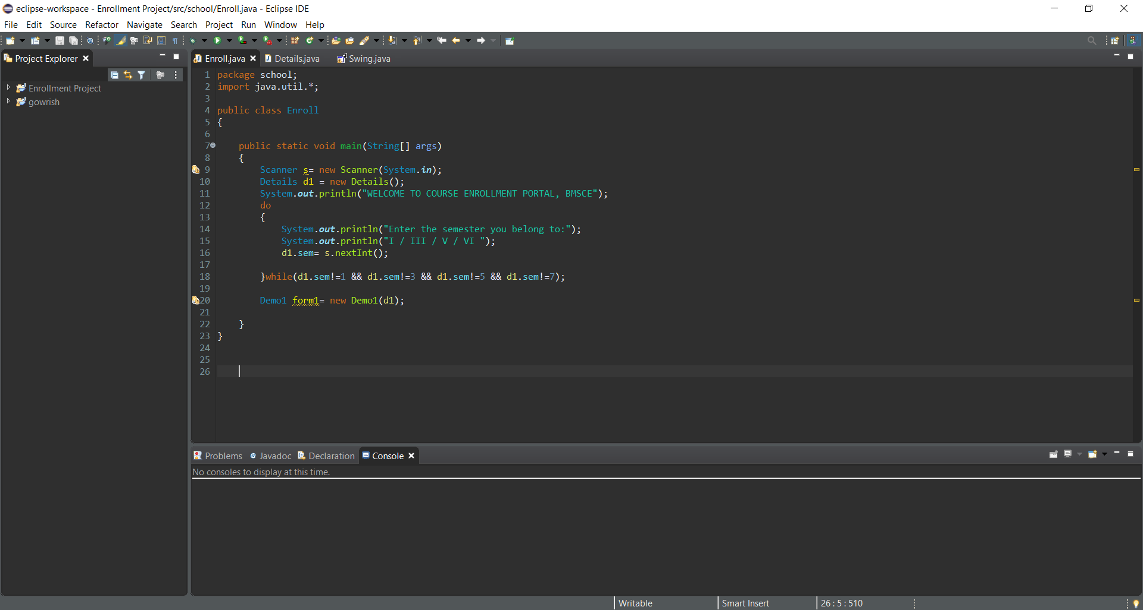

**7. Results/ Output**

Freshers’ Enrolment Output:

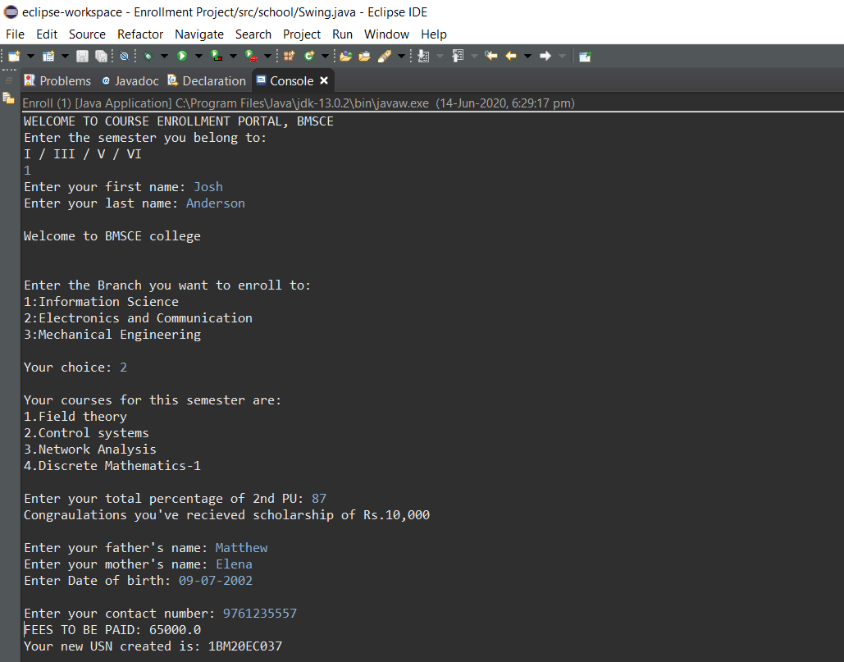

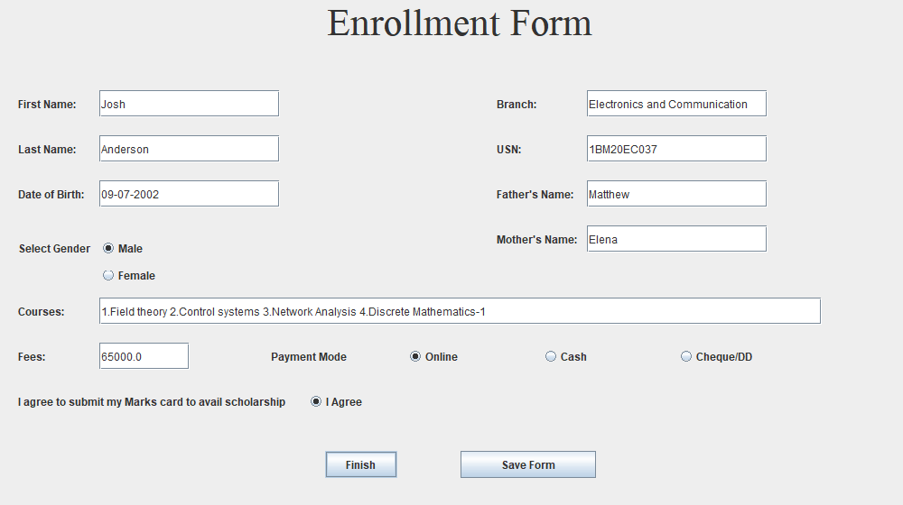

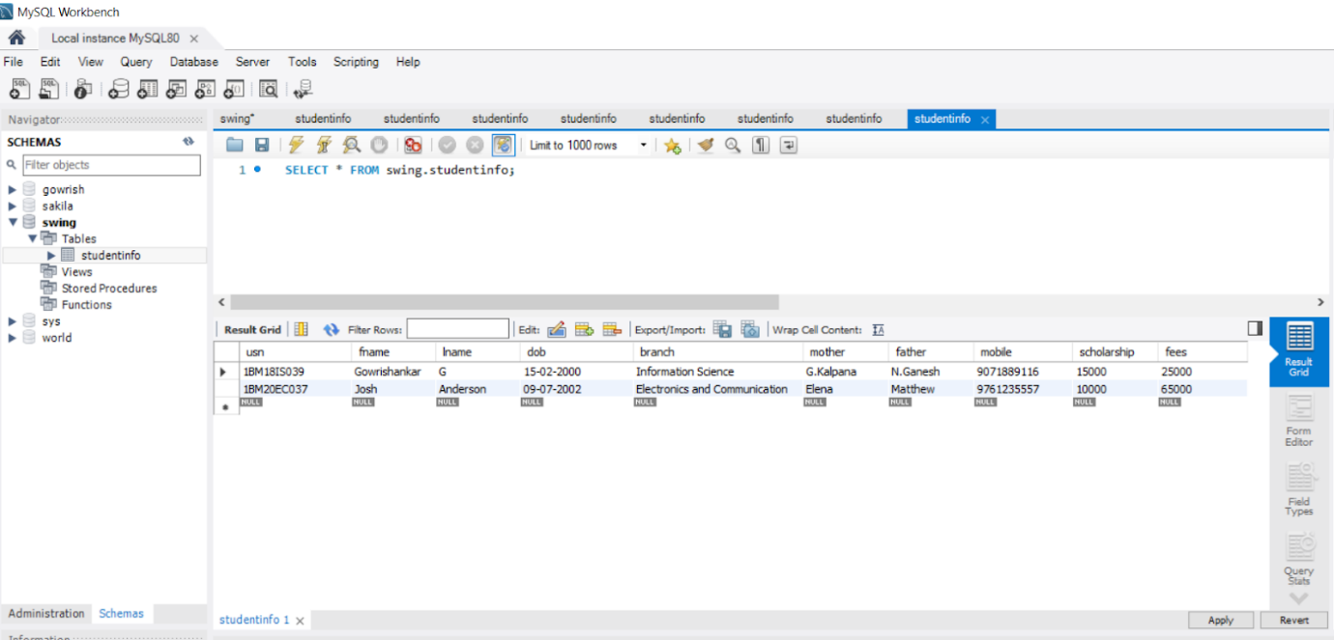

Seniors’ Course Registration Output:

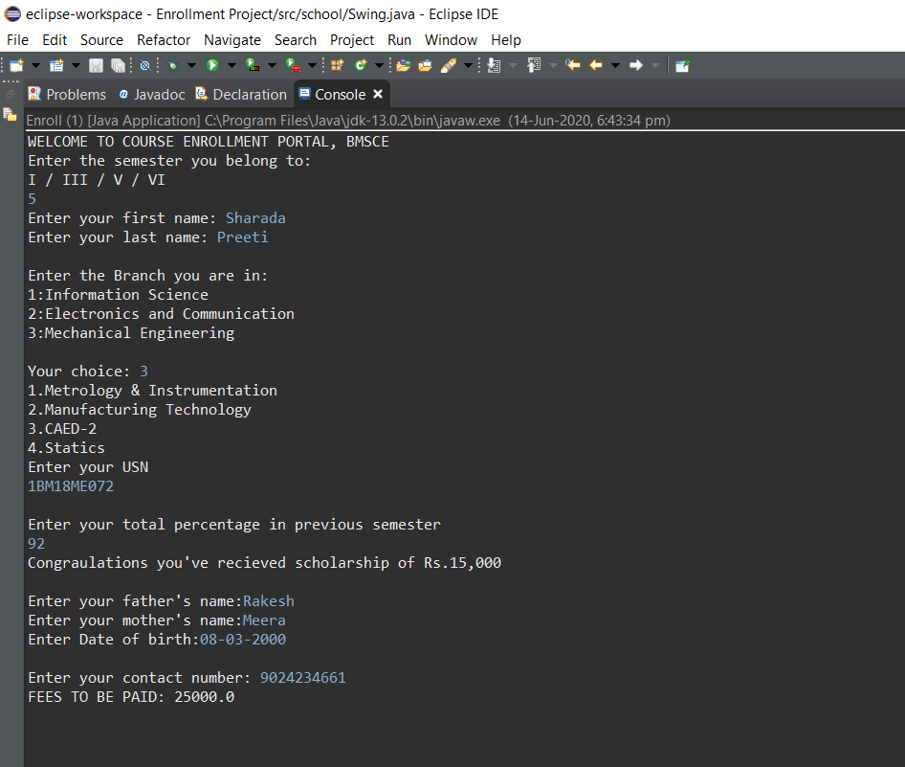

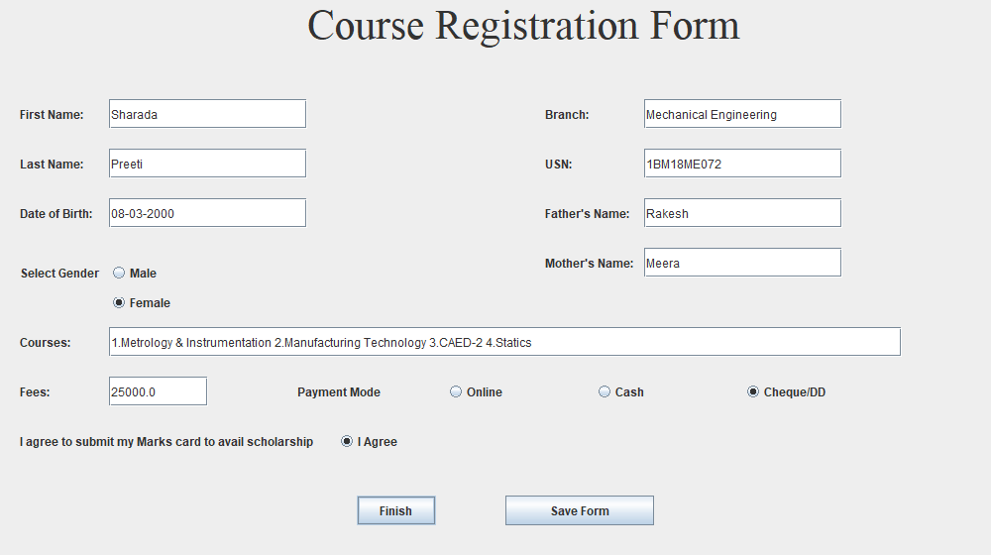

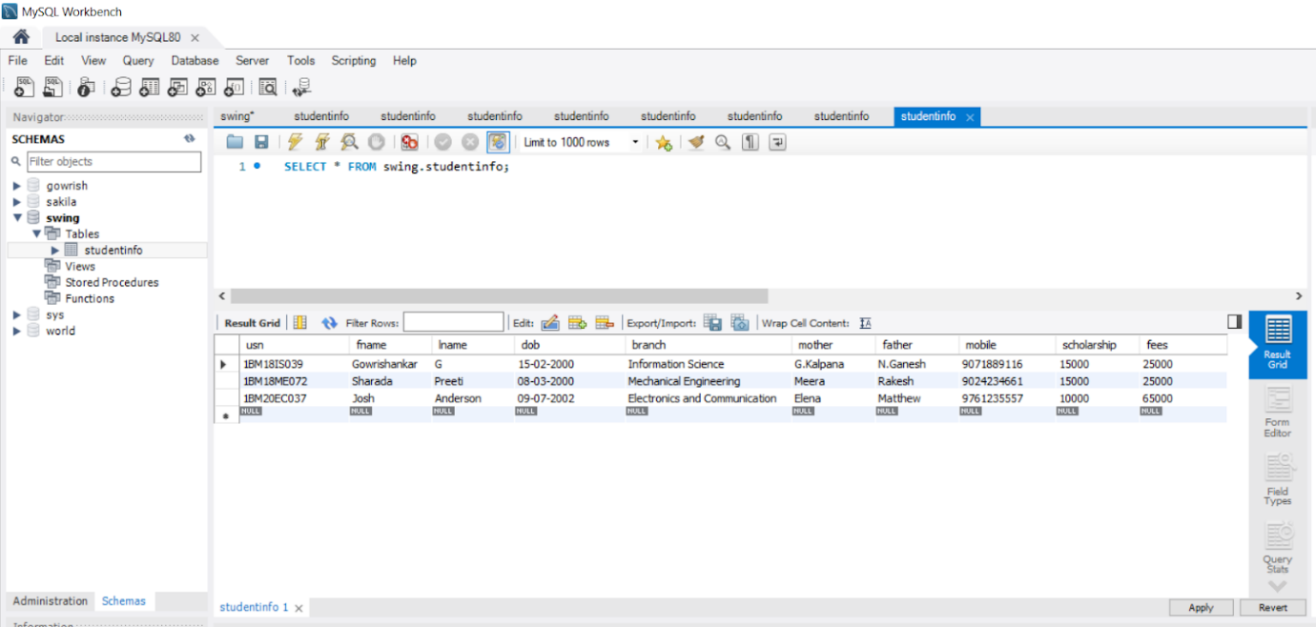

**8. References**

* <https://www.javatpoint.com/java-swing>
* <https://www.tutorialspoint.com/swing/index.htm>